Library for Environmental Practices and Circular Economy

Introduction
Escape4Change is a socially driven startup specialized in the design and development of educational escape games, with the goal of raising awareness and promoting learning through play. Our games are based on the learning by playing approach, which fosters active engagement and helps players develop practical and transversal skills related to the topic being addressed.

Environmental Game Design Methodology

Escape Games
Escape games, by their very nature, are particularly effective when it comes to educating players on complex and emotionally engaging topics such as environmental awareness, sustainability, and climate change. Through immersive storytelling, time-bound challenges, and collaborative problem solving, players are placed in scenarios that stimulate critical thinking, teamwork, and personal reflection. This creates a deeper and more lasting understanding of environmental issues.
We design escape games in various formats–physical, digital, and hybrid–suitable for both formal and informal educational settings, including schools, youth centers, and public events. Each game is developed with the aim of delivering accurate environmental content while encouraging sustainable behavior in everyday life.
In summary, our methodology combines immersive gameplay with environmental education, helping to shape more aware and responsible citizens through a hands-on, engaging, and memorable experience.

Challenges and Scenarios
When designing our escape games at Escape4Change, we always strive to create scenarios that actively engage players and immerse them in meaningful experiences. This is made possible through a careful analysis of the target audience for each specific project. Understanding the players' age, background, and context allows us to tailor the game dynamics, language, and challenges to ensure maximum relevance and impact.
The challenges we design are not just puzzles to solve - they are embedded in realistic or symbolic situations that reflect real-world situations. By putting players in decision-making roles within these scenarios that they actually know or are interested in, we encourage them to explore the consequences of actions, develop critical thinking, and gain a deeper understanding of the environmental problems at hand.
This approach ensures that each escape game becomes more than just a game: it becomes a transformative learning experience that leaves a lasting impression on the players.

In-game Decisions
Thanks to our hands-on and action-oriented approach, players in our escape games are not only told about sustainable behaviors-they are asked to practice them. The design of our games allows players to see the immediate consequences of their in-game decisions, reinforcing the connection between actions and outcomes.
This real-time feedback mechanism plays a crucial role in raising players’ awareness and sense of responsibility. They begin to understand that their choices matter, not only within the game but also in real life. By placing players at the center of the challenge, we empower them to become active agents of change, making sustainability something they do, not just something they learn about.
In this way, our games promote meaningful reflection and help translate in-game experiences into real-world sustainable behavior.

Examples of In-game Mechanics
At Escape4Change, we design game mechanics that emulate meaningful actions and align closely with real-world environmental challenges. Our goal is to create experiences that not only entertain but also raise awareness and promote critical thinking about ecological issues.
In our experience, mechanics such as resource management, measuring the impact of human activity, and quantifying food waste have proven particularly effective. These elements allow players to engage with the complexities of sustainability in a hands-on way-making choices, facing consequences, and discovering the importance of balance and responsibility.
By integrating these kinds of mechanics into immersive scenarios, we help players develop an ecological mindset and a deeper understanding of the systems that sustain our planet.

Incorporate Environmental Topics into Gameplay
When clients assign us environmental topics to focus on, our design team conducts an in-depth analysis to fully understand the subject. This research informs the integration of key findings into gameplay mechanics and dynamics. For example, players may encounter scenarios that simulate real-world actions they can replicate to address environmental challenges or discover essential data and messages required to solve the game's core problem.

Make Environmental Themes Engaging
Our games are rooted in the "learning by playing" methodology, which means they are designed to entertain while also educating players. Each experience is carefully tailored to align with the target audience, ensuring maximum engagement and relevance. By immersing players in meaningful narratives and real world situations, we encourage them to interact with and reflect on environmental themes in a way that feels personal and impactful.

Measure Games effectiveness
At Escape4Change, we believe it is essential to assess the learning outcomes and awareness gained by our players. One of the most effective methods we use is a structured debriefing phase at the end of each game experience. During the debrief, we engage participants in a guided discussion to reflect on the game, the decisions they made, and the environmental issues they encountered.
The debrief is carefully designed with targeted questions that align with the key messages and educational goals of the game. This allows us to evaluate not only what players learned, but also how their perceptions and attitudes may have shifted.
In addition to live discussions, we often use self-administered feedback forms that players fill out individually. These forms help us collect both quantitative and qualitative data on the effectiveness of the game, providing valuable insights for future improvements.
This combined approach ensures that our escape games are not only engaging, but also impactful in promoting deeper environmental awareness.

Good Partnership
At Escape4Change, we often collaborate with organizations that are deeply involved in environmental activism and education. These partnerships are essential to ensuring the accuracy, relevance, and credibility of the content within our games.
The knowledge and insights we gain from these organizations allow us to enrich our scenarios with real-world data, meaningful narratives, and impactful challenges. These collaborations not only enhance the educational value of our games but also help us align our messages with current environmental priorities and best practices.
Moreover, working with these partners strengthens the promotion and outreach of our projects, allowing us to reach a wider audience and amplify the positive impact of our educational escape games.

The Power of Social Media
At Escape4Change, we recognize the power of social media as a key tool for reaching the right target audience and amplifying the impact of our initiatives. By crafting tailored messages and campaigns, we can effectively engage communities, raise awareness, and boost participation in events featuring our educational escape games.
Collaborating with the social media channels of our partners further strengthens this strategy, expanding our reach and reinforcing the credibility of our message.

Conclusions and Recommendations
Escape4Change’s experience in designing educational escape games demonstrates that game-based learning can be a powerful tool for raising environmental awareness and encouraging sustainable behaviors. Our methodology, rooted in immersive storytelling, hands-on decision making, and real-world relevance, has proven effective in engaging diverse audiences and promoting meaningful reflection.
To those interested in developing or supporting environmental game-based initiatives, we offer the following recommendations based on our practices:
- Design with Your Audience in Mind
Always begin with a clear understanding of your target audience—age, interests, background, and learning needs. Tailoring the language, challenges, and narrative to your players maximizes engagement and impact.
- Embed Real-World Relevance into Gameplay
Create scenarios and challenges that mirror real-life environmental problems. This helps players connect emotionally with the issue and understand the practical consequences of their actions.
- Encourage Active Decision-Making
Design game mechanics that place players in roles where they must make choices and experience their outcomes. This promotes a deeper sense of responsibility and awareness.
- Partner with Experts
Collaborate with environmental organizations, educators, or researchers to ensure that your content is accurate, up-to-date, and aligned with real environmental needs and solutions.
- Use Debriefing to Deepen Impact
After gameplay, guide players through a structured reflection on what they experienced, the decisions they made, and how these relate to real-world behavior. This phase is essential for solidifying learning.
- Leverage Social Media and Community Networks
Use social media strategically to promote your games and spread awareness. Partnering with organizations that share your values can help amplify your message and reach new audiences.
- Evaluate and Adapt
Collect feedback and measure learning outcomes wherever possible. Use this data to continuously improve your games and adapt them to new contexts and challenges.
By following these recommendations, educators, designers, and organizations can harness the full potential of game-based learning to educate, engage, and empower individuals in the fight for a more sustainable future.

Environmentally Conscious Games Examples
Carbon City Zero
Webpage/source: | https://boardgamegeek.com/boardgame/288179/carbon-city-zero
Company or organization that has developed the game | Possible
Type of game | Collaborative card game
Description | Carbon City Zero is a card game where players take on the role of mayors working to develop sustainable cities. By collaborating, they must transform transportation, industries, and engage citizens to achieve net-zero carbon emissions..
Environmental Features Checklist | Education on urban decarbonization  Promotion of collaboration for sustainability  Emphasis on practical solutions to reduce emissions
Images (1/good practice) | 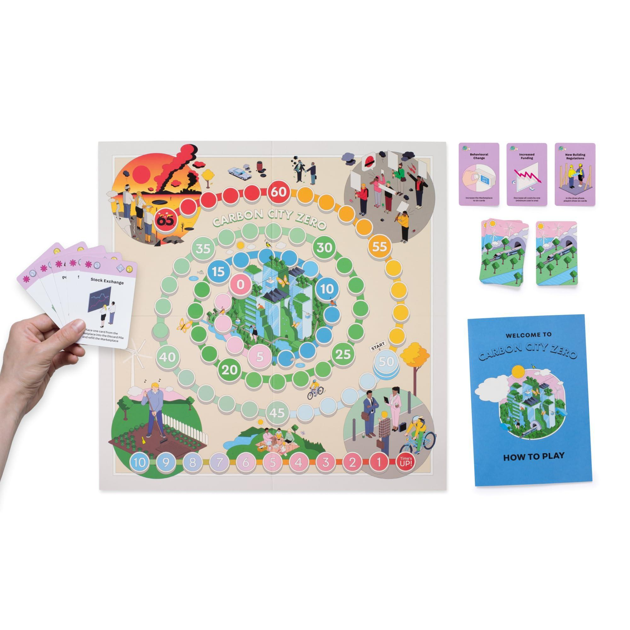

Econauti
Webpage/source: | https://docs.google.com/presentation/d/1b5T5cSWTWasuHPK_AiE5T_xMnlWzAwg4/edit#slide=id.g2dca2530a39_0_62
Company or organization that has developed the game | Escape4Change
Type of game | Educational Escape Box
Description | Econauti is an educational escape box where players must solve various puzzles related to the environmental issues caused by pollution on planet Earth. By working together, they uncover details about the different phenomena that have contributed to pollution, ultimately revealing a message of hope for the future.
Environmental Features Checklist | Raising awareness about different types of pollution  Encouraging the shift away from environmentally harmful habits  Highlighting the issues caused by various forms of pollution
Images (1/good practice) | 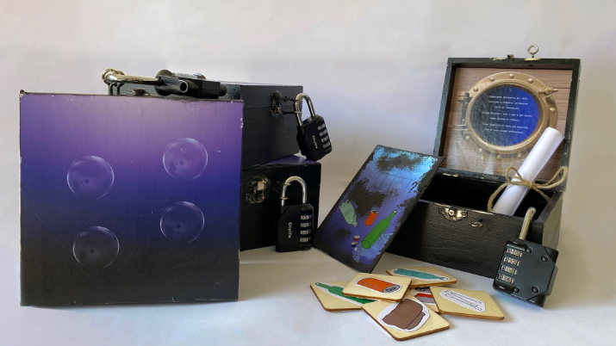

Ecogon
Webpage/source: | https://boardgamegeek.com/boardgame/211453/ecogon
Company or organization that has developed the game | Gaiagames
Type of game | Strategic board game
Description | Ecogon is a strategic game where players build and manage their own ecosystem by introducing habitats, animals, and plants. The goal is to create a sustainable ecological balance while facing challenges such as biodiversity and species interactions. The game emphasizes the importance of conservation and responsible ecosystem management.
Environmental Features Checklist | Education on biodiversity and ecosystems  Promotion of sustainable resource management  Awareness of ecological interactions
Images (1/good practice) | 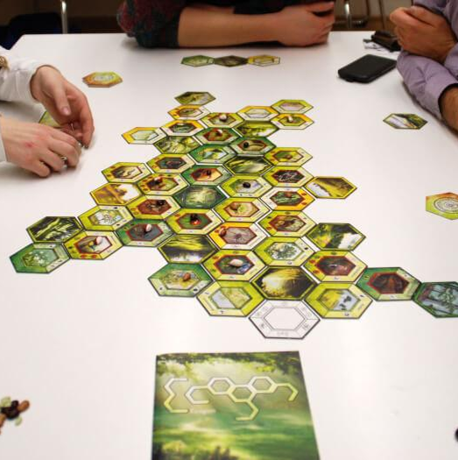

Circular Economy Game Design Methodology

Escape Games
At Escape4Change, we specialize in creating immersive escape games, such as escape rooms. These experiences are designed to raise awareness about social and environmental issues while fostering the development of new soft skills through the "learning by playing" method. By combining engaging narratives with actionable insights, we aim to educate and entertain, leaving players with both a memorable experience and a deeper understanding of the topics addressed.

Material Choices
By working with local artisans, we can collaborate closely to select materials and production methods that align with circular economy principles. We prioritize recycled, upcycled, and repurposed materials in the prototyping phase, ensuring that every element in our games supports local circular ecosystems. This approach minimizes waste and promotes sustainable production within the local economy.

Packaging
Our escape experiences do not require specific packaging. Escape rooms are modular and assembled on-site, eliminating the need for disposable packaging. Our portable escape boxes are designed to be lightweight and easy to transport, reducing packaging waste while ensuring reusability.

Production methods and their environmental impact
We emphasize designing for durability and modularity. By creating escape room components that can be reused, modified, or repurposed, we extend the lifespan of our game elements. Rather than producing single-use props, we develop multi-functional, adaptable assets that can be integrated into different experiences, reducing the need for constant production of new materials.

Incorporate Circular Economic Topics into Gameplay
When clients request circular economy-themed games, our design team conducts in-depth research and topic deconstruction. We break down complex concepts into digestible mechanics that players can engage with. These insights are then integrated into gameplay mechanics and dynamics, where players:
- Simulate real-world circular economy actions that can be applied outside the game.
- Solve challenges based on resource optimization, recycling, and sustainability principles.
- Discover key facts and messages that drive home the importance of transitioning to a circular economy.

Educational Aspects About Circular Economy
To help players understand the benefits of a circular model versus a linear economy, we analyze successful case studies from real-world examples. By identifying the key strategies that made these businesses or initiatives successful, we extract applicable methodologies and translate them into engaging game mechanics. This approach allows players to learn useful knowledge through play, reinforcing key circular economy principles in a fun and interactive way.

Player Engagement with Circular Economy Themes
Our games follow the "learning by playing" methodology, ensuring that educational content is seamlessly integrated into an entertaining and engaging experience. Each escape game is carefully designed to:
- Captivate players with immersive storytelling and mechanics.
- Adapt to the target audience, making circular economy concepts relatable and impactful.
- Encourage players to think critically and apply circular economy principles beyond the game.

Lifecycle Analysis
Our escape games are delivered to clients with long-term usability in mind. Each game is easy to repair, update, and modify, allowing it to be set up and dismantled efficiently. This prolongs the lifespan of our products, reducing waste and supporting sustainable game experiences.

Instructions to Reuse and Repurposing of Game Materials
Our games require minimal maintenance, and we provide detailed manuals explaining how to replace or repair damaged components. By offering straightforward repair and customization guidelines, we ensure that our escape games remain sustainable and functional over time, reducing unnecessary disposal.

Conclusions and Recommendations
Escape4Change demonstrates how circular economy principles can be integrated into every stage of game design, from material selection to gameplay mechanics. By prioritizing upcycling, modular design, and long-lasting game components, we create sustainable and adaptable gaming experiences.
For organizations and game designers seeking to promote circular economy concepts, we recommend:
- Prioritizing materials that can be repurposed, recycled, or sourced sustainably.
- Providing instructions for reuse, repairs, and repurposing, minimizing waste at the end of a game’s lifecycle.
- Designing games with longevity in mind, ensuring ease of maintenance and adaptability.
- Integrating circular economy themes into gameplay, encouraging players to reflect on sustainable solutions.
By adopting these practices, the industry can play a crucial role in promoting sustainability and circular economy values, inspiring both creators and players to embrace more responsible consumption habits.

Circular Economy Games Examples
In the Loop
Webpage/source: | https://intheloopgame.com/
Company or organization that has developed the game | In the Loop Game
Type of game | Board Game
Description | In the Loop is a serious game that introduces players to circular economy concepts such as systems thinking, remanufacturing, and critical materials. Players take on the role of manufacturing companies striving to collect resources and build products while considering sustainable practices. The game sparks discussions about resource use and challenges players to find solutions within a simulated global supply chain.
Circular Economy Features Checklist | Highlights importance of sustainable resource management  Encourages systems thinking and strategic planning  Facilitates understanding of global supply chain dynamics
Images | 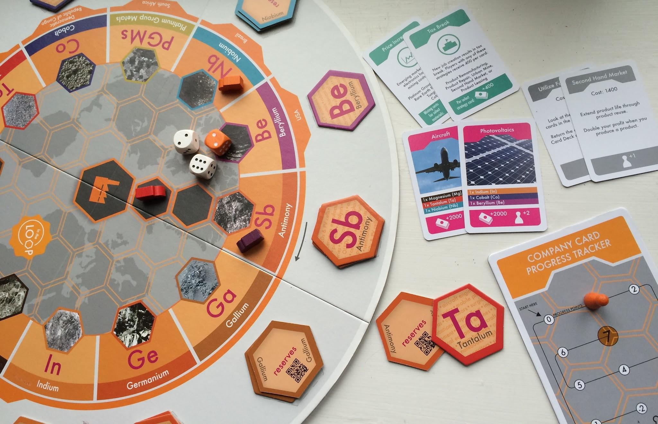

ecoCEO
Webpage/source: | https://ecoceo.vito.be/en/ecoceo-game
Company or organization that has developed the game | VITO
Type of game | Educational Board Game
Description | ecoCEO is an interactive and engaging educational game designed for the classroom to increase awareness and transfer knowledge about circular economy strategies. Players manage a virtual company, making decisions on resource use, production, and waste management to implement circular economy practices. The game aims to educate students on sustainable business strategies and the importance of resource efficiency.  ecoCEO is also available online for free in more than 20 languages and does not require any prior installation. A single teacher can handle up to 35 teams at the same time.
Circular Economy Features Checklist | Educates on circular economy business strategies  Simulates decision-making in resource management  Promotes awareness of sustainable production practices
Images | 